## CAMPUS NAVIGATOR

**Main Project Report**

**Submitted by**

### Aswathy K

**Reg No : FIT22MCA-2036**

*Submitted in partial fulfillment of the requirements for the award of the degree of*

***Master of Computer Applications of***

***A P J Abdul Kalam Technological University***



#### FEDERAL INSTITUTE OF SCIENCE AND TECHNOLOGY (FISAT)ⒸR

**ANGAMALY - 683577, ERNAKULAM (DIST.)**

#### MAY 2024

**DECLARATION**

I Aswathy K , hereby declare that the report of this project work, submitted to the Department of Computer Applications, Federal Institute of Science and Technology (FISAT), Angamaly in partial fulfillment of the award of the degree of Master of Computer Applications is an authentic record of my original work.

The report has not been submitted for the award of any degree of this university or any other university.

Date : 18/04/2024

Place : Angamaly Aswathy K

**FEDERAL INSTITUTE OF SCIENCE AND TECHNOLOGY (FISAT)®**

#### ANGAMALY, ERNAKULAM-683577

**DEPARTMENT OF COMPUTER APPLICATIONS**



**CERTIFICATE**

*This is to certify that the project report titled* ***’CAMPUS NAVIGATOR’*** *submitted by Aswathy K (Reg No.FIT22MCA-2036) towards partial fulfillment of the requirements for the award of the degree of Master of Computer Applications is a record of bonafide work carried out by her during the year 2024.*

Project Guide Head of the Department

Dr. DEEPA MARY MATHEW Dr. DEEPA MARY MATHEW

*Submitted for the viva-voice held on ................... at ....................*

Examiner :

#### ACKNOWLEDGEMENT

I am extremely glad to present my main project which I did as a part of our curriculum. I take this opportunity to express my sincere thanks to those who helped me in bringing out the report of my project.

I am deeply grateful to **Dr. Jacob Thomas V**, Principal, FISAT, Angamaly and **Dr. Mini P R**, Vice Principal, FISAT, Angamaly.

My sincere thanks to **Dr. Deepa Mary Mathew**, Head of the department of MCA, FISAT, who had been a source of inspiration. During the period of my project work, I have received generous help from **Dr. Deepa Mary Mathew**, my project guide, which I like to put on record here with deep gratitude and great pleasure.

My special gratitude to **Mr. Santhosh Kottam**, for his encouragement and suggestions. I express my heartfelt thanks to all the faculty members in our department for their constant encouragement and never ending support throughout the project.

Finally I am grateful to all my friends who gave me a lot of suggestions for the successful completion of this project.

Aswathy K

#### ABSTRACT

The "Campus Navigator" mobile application revolutionizes campus navigation by offering a seamless experience tailored to the needs of students and staff. By digitizing traditional paper-based processes, such as bus pass requests and concession card management, the app enhances efficiency and convenience. Users can now effortlessly purchase passes and manage transactions securely within the app, eliminating the hassle of physical passes and reducing the risk of loss or damage.

Moreover, the transition to digital solutions extends to concession card services, allowing users to easily apply for and download digital copies for added convenience. This evolution not only simplifies administrative tasks but also enhances user experience by offering a streamlined process. Faculty members also benefit from the app's functionality, as they can efficiently book campus vehicles for official purposes, thereby increasing productivity and optimizing resource utilization.

Overall, the "Campus Navigator" sets a new standard for campus navigation applications with its emphasis on functionality, accessibility, and visual appeal. By prioritizing user experience and leveraging digital solutions, the app delivers a delightful and efficient navigation experience for all users, marking a significant advancement in campus management technology.

# Contents

1. INTRODUTION 1
2. PROOF OF CONCEPT 3
   1. Existing System… 4
   2. Proposed System… 6
   3. Objectives 7
3. IMPLEMENTATION 9
   1. Modules 11
      1. Survey Management Module 11
      2. Marketing Management Module 12
      3. Complaint Handling Module 13
      4. Calendar Integration Module 14
      5. Reports and Analysis Module 15
   2. Issues Faced and Remedies Taken 16
      1. Issues 16
      2. Remedies 17
4. RESULT ANALYSIS 18
5. CONCLUSION AND FUTURE SCOPE 20
   1. Future Scope 21
6. APPENDIX 22
   1. Sourcecode 22
      1. Module 1 : Survey.dart 22
      2. Module 2 : Marketing.dart 23
      3. Module 3 : Calender.dart 26
      4. Module 4 :Complaint.dart 27
      5. Module 5: Report Analytics… 29
   2. Screenshots 32
7. REFERENCES 40

**Chapter 1 INTRODUTION**

In an era characterized by rapid technological advancement and digital transformation, the traditional methods of campus navigation and management are being reimagined to meet the evolving needs of students, faculty, and staff. Recognizing the challenges posed by outdated paper-based systems, we embarked on a journey to develop the "Campus Navigator" mobile application—a cutting-edge solution meticulously crafted to streamline navigation processes within the campus environment. This project report provides a comprehensive overview of our endeavor to revolutionize campus navigation through the implementation of digital and contactless solutions.

The "Campus Navigator" represents a paradigm shift from conventional paper-based systems to modern, technology-driven approaches. Our primary objective was to enhance efficiency, convenience, and accessibility for all users, while also minimizing administrative burdens and improving resource utilization. By leveraging the latest advancements in mobile technology, we aimed to create an intuitive, user-friendly platform that sets a new standard for campus navigation applications.

This report outlines the key features and functionalities of the "Campus Navigator" app, including its transition from paper-based bus passes to digital transactions, digitized concession card management, and streamlined campus vehicle booking services for faculty members. We will delve into the rationale behind each feature, the development process, and the anticipated impact on the campus community.

Through the "Campus Navigator" project, we aim to not only simplify navigation processes but also foster a culture of innovation and efficiency within the campus environment. By embracing digital solutions and prioritizing user experience, we believe that the app has the potential to significantly enhance the overall campus experience for students, faculty, and staff alike. Join us as we embark on this transformative journey towards a more connected, efficient, and sustainable campus ecosystem with the "Campus Navigator" mobile application

# Chapter 2

**PROOF OF CONCEPT**

In the initial stages of conceptualizing the "Campus Navigator" mobile application, it was imperative to ascertain the feasibility and effectiveness of our envisioned digital navigation solution. Through a meticulously planned series of proof of concept (POC) demonstrations, we embarked on a journey to validate the potential transformation from conventional paper-based systems to innovative digital and contactless solutions. Our primary objective was two-fold: to deeply understand the intricate navigation challenges faced by users within the dynamic campus environment, and to evaluate the technological landscape for implementing robust digital solutions seamlessly.

Our exploration began with an in-depth analysis of user needs, conducted through a combination of surveys, interviews, and focus group discussions. These interactions unveiled a profound desire among users for a centralized, intuitive navigation platform that not only simplifies transactions but also provides real-time updates and information pertinent to their navigation needs. Users expressed frustration with the cumbersome nature of traditional paper-based systems and eagerly embraced the prospect of digital solutions that promised enhanced convenience and accessibility.

Simultaneously, we delved into the technological feasibility of our proposed digital navigation solution. This involved a comprehensive assessment of existing mobile app development frameworks, payment gateways, and security protocols. Through rigorous evaluation and testing, we identified the most suitable technological tools and platforms to ensure a seamless user experience while prioritizing data security and privacy.

3

In conclusion, the proof of concept demonstrations provided compelling evidence of the feasibility and efficacy of the "Campus Navigator" mobile application. By meticulously addressing user needs and leveraging cutting-edge mobile technologies, we demonstrated the transformative potential of digital solutions in revolutionizing campus navigation and management processes. These findings not only informed subsequent development and implementation phases but also served as a testament to our commitment to delivering a seamless and delightful navigation experience for the campus community.

## Existing System

## In the current landscape of campus navigation and management, reliance on traditional paper-based systems prevails. Students, faculty, and staff navigate the campus environment using physical bus passes and concession cards, with manual processes dictating their issuance and management. Bus passes, often paper-based and prone to wear and tear, require physical possession and are subject to loss or damage. Similarly, concession cards, utilized for various campus services and facilities, are managed through paperwork, necessitating manual application processes and document handling. This reliance on physical documentation not only introduces inefficiencies but also poses challenges in terms of accessibility, security, and environmental sustainability.

Moreover, faculty members seeking to book campus vehicles for official purposes encounter administrative hurdles, relying on manual booking procedures that may lack real-time availability updates and efficient reservation management. The inefficiencies inherent in these paper-based processes not only hinder productivity but also contribute to a disjointed and cumbersome navigation experience for all users. The absence of digital solutions not only impedes the optimization of resources but also limits the ability to provide seamless, real-time services to the campus community.

In summary, the existing system of campus navigation and management revolves around traditional paper-based processes for bus passes, concession cards, and campus vehicle bookings. While these systems have served their purpose to a certain extent, they are fraught with inefficiencies, limitations, and vulnerabilities. The reliance on physical documentation and manual procedures impedes accessibility, security, and productivity, highlighting the pressing need for a transformative digital solution like the "Campus Navigator" mobile application.

## Proposed System

The proposed "Campus Navigator" mobile application represents a paradigm shift from traditional paper-based systems to innovative digital and contactless solutions, aimed at revolutionizing campus navigation and management. Central to this transformation is the digitization of bus passes and concession card management, which eliminates the need for physical documentation and streamlines transaction processes. Through the app, users can seamlessly purchase and manage their bus passes, reducing the risk of loss or damage while enhancing accessibility and convenience. Importantly, students no longer need to endure long waiting times to acquire their bus passes, as transactions are processed swiftly within the app, ensuring a seamless experience.

Similarly, concession card services are digitized, allowing users to apply for and manage their cards within the app, with the option to download digital copies for added convenience and flexibility. Furthermore, the "Campus Navigator" app facilitates campus vehicle bookings for faculty members, enhancing efficiency and productivity. By digitizing the booking process, faculty members can conveniently reserve campus vehicles for official purposes, with real-time availability updates and efficient reservation management. This feature not only optimizes resource utilization but also provides a seamless booking experience for faculty, contributing to overall operation efficiency within the campus environment.

Overall, the proposed system emphasizes functionality, accessibility, and efficiency, setting a new standard for campus navigation applications. By leveraging digital and contactless solutions, the "Campus Navigator" app offers a transformative navigation experience that enhances convenience, reduces administrative burdens, and fosters a more connected and efficient campus ecosystem.

## OBJECTIVES

Objectives of Campus Navigator App is:

1. Enhance User Experience: The primary objective of the "Campus Navigator" app is to significantly improve the navigation experience for students, faculty, and staff within the campus environment. By transitioning from traditional paper-based systems to digital and contactless solutions, the app aims to streamline processes, reduce waiting times, and enhance overall convenience for users.
2. Streamline Transaction Processes: The app seeks to simplify transaction processes associated with bus pass requests, concession card management, and campus vehicle bookings. By digitizing these processes, users can seamlessly purchase passes, apply for concession cards, and book campus vehicles within the app, eliminating the need for manual paperwork and reducing administrative burdens.

3.Increase Accessibility and Efficiency: Another key objective is to increase accessibility and efficiency in campus navigation and management. The app provides users with easy access to essential navigation tools and services, such as real-time bus pass purchases, digital concession card management, and streamlined vehicle booking processes for faculty members. This accessibility enhances user productivity and contributes to a more connected campus community.

4.Optimize Resource Utilization: The "Campus Navigator" app aims to optimize the utilization of campus resources, particularly in the context of transportation services. By offering real-time availability updates and efficient reservation management for campus vehicles, the app ensures optimal use of resources while reducing idle time and enhancing operational efficiency.

5.Promote Sustainability: By transitioning from traditional paper-based systems to digital solutions, the app contributes to environmental sustainability by reducing paper consumption and waste. Digital bus passes, concession cards, and vehicle bookings not only offer convenience but also align with the campus's commitment to sustainability and eco-friendly practices.

6.Enable PDF Downloading: Additionally, the app enables users to download

PDF copies of their digital bus passes and concession cards for offline

access and record-keeping purposes.

# Chapter 3

**IMPLEMENTATION**

The "Campus Navigator" mobile application is built upon a robust and modern technology stack, utilizing Flutter for frontend development, Node.js for backend development, and MongoDB for database management. Flutter, a cross-platform framework, is employed to create a highly responsive and visually appealing user interface. Leveraging Flutter's pre-designed widgets and tools, developers customize UI components to match the app's branding and design specifications, ensuring a seamless user experience. Additionally, Flutter's hot reload feature facilitates rapid development and iteration, allowing

On the backend, Node.js serves as the foundation for implementing scalable and high-performance server-side logic. Developers utilize Express.js, a lightweight web application framework, to create RESTful APIs that handle requests from the frontend and interact with the MongoDB database. With Node.js, authentication, user management, and business logic are efficiently implemented to ensure security and data integrity.

9

MongoDB, a NoSQL database, is employed to store and manage various types of data, including user profiles, bus pass information, concession card details, and vehicle booking records. MongoDB's flexible document-based data model enables developers to represent complex hierarchical relationships and nested structures, facilitating efficient data retrieval, manipulation, and aggregation operations.

Additionally, middleware integration with Express.js handles cross-cutting concerns such as logging, request validation, and error handling, enhancing security and consistency. Input data validation and sanitization prevent security vulnerabilities, while caching mechanisms optimize performance by storing frequently accessed data in memory. Asynchronous task processing offloads time-consuming tasks to worker threads or external task queues, ensuring responsiveness and scalability. Advanced security features such as rate limiting and HTTPS enforcement mitigate security risks, while horizontal scaling techniques and comprehensive monitoring solutions ensure reliability, fault tolerance, and performance optimization.

## MODULES

The "Campus Navigator" mobile application comprises several modules, each serving a specific function or feature to facilitate seamless navigation and management within the campus environment. These modules include:

### User Module

* This module ensures the security of the app by verifying the identity of users before granting access to its features and functionalities.Users are required to log in with their credentials, such as email and password, which are securely stored and authenticated against a database.
* User roles and permissions are defined to regulate access to different parts of the app based on the user's role within the campus community (e.g., student, staff).
* Secure Signup Process: Users can register for an account by providing essential information such as their full name, admission number, user type (hostler, day scholar, staff), email address, and a secure password.

**3.2.2 Bus Pass Management**

* Purchase the pass: Users can effortlessly purchase new bus passes or renew existing ones directly through the app. They provide essential details such as their name, admission number, department, and desired travel route (from and to). Additionally, users specify the start date of their pass, and based on this, the module calculates and displays the expiration date.
* Pass Generation and Submission: Upon submission of the requisite details, the module generates a form embodying the user's provided information. This form serves as a record of the pass application, containing vital data such as user details, travel route, and pass duration. Users review and verify the accuracy of the information before proceeding to payment.

* Payment Processing: Following the completion of the pass application form, users proceed to payment processing. The module seamlessly integrates with payment gateways to facilitate secure transactions. Users select their preferred payment method, and the system ensures the protection of sensitive financial information

**3.2.3Concession Card Management**

* Application Process: Users initiate the application process by providing essential details such as their name, admission number, department, and place of residence. Additionally, users may input their preferred bus number for commuting purposes. These details are crucial for validating eligibility and processing the concession card request.
* PDF Generation: Upon submission of the application form, the module generates a PDF document containing the user's provided information. This PDF serves as a comprehensive record of the concession card application, including all relevant details such as user particulars, department, place , and preferred bus number. Users have the option to download and retain this document for their records.

**3.2.4 Request Submission for Students**

* This module enables students to submit requests for special events, such as industrial visits, placements, or academic excursions, directly through the app.Students can specify the purpose, date, and other relevant details of the event, and submit the request to the respective Head of Department (HOD) or tutor for approval.

* Routing to HOD and Tutor: Upon submission, the request is automatically routed to the respective Head of Department (HOD) and tutor for review and approval. The module leverages the student's email address associated with their account to seamlessly send the request to the designated authorities for further processing.

### 3.2.5 Vehicle Booking

* The campus vehicle booking module enables faculty members to book campus vehicles for official purposes, such as academic conferences, field trips, or research projects.Users can check vehicle availability, select the desired vehicle type and date/time, and submit booking requests directly through the app.
* Notification to Administrative and HOD: Upon submission, the booking request is automatically forwarded as an email notification to the administrative department responsible for vehicle allocation and the respective Head of Department (HOD) for review and approval.

**3.2.6 Admin Module**

* User Management: Administrators can access and view all registered hostlers and dayscholars within the app. The dashboard displays detailed profiles of each user, including personal information, contact details, and enrollment status. Administrators have the authority to perform actions such as account activation, deactivation, or deletion as necessary**.**
* Search Functionality: The dashboard incorporates a powerful search feature that allows administrators to quickly locate specific user profiles based on criteria such as name, admission number, or department. This search functionality streamlines the process of retrieving userinformation and facilitates efficient management of user accounts**.**

* Bus Pass Search for Hostlers: Administrators can utilize a dedicated search option to query bus pass details for hostlers. By entering the origin and destination points (from and to), administrators can retrieve information about hostlers who have purchased bus passes for specific routes. This feature enables administrators to track bus pass usage and monitor transportation patterns within the campus community.
* Concession Card Management: Administrators have the authority to manage concession cards for individual students. In cases where a concession card needs to be revoked or deleted, administrators can perform the necessary actions directly from the dashboard. This feature ensures that administrators can maintain accurate records of concession card holders and manage card issuance effectively.

important dates, appointments, and work schedules related to packing and moving services, ensuring efficient coordination and timely execution of tasks.

* Scheduling and Event Management:

At the core of the Calendar Integration Module is the ability to schedule and manage various events and tasks associated with packing and moving operations. Staff members can input important dates such as survey appointments, packing dates, moving dates, and other relevant events directly into the application's calendar interface. Each event can be categorized, labeled, and assigned specific details to provide clarity and context for users.

* Real-time Visibility and Notifications:

The module offers real-time visibility into scheduled events and tasks, allowing staff members to stay informed and organized at all times. Users can view their upcoming appointments and tasks within the application's calendar interface, ensuring they are aware of their responsibilities and commitments. Additionally, the module supports notifications and reminders to alert staff members of upcoming events, ensuring they never miss important deadlines or appointments.

### Reports and Analysis Module

* Real-time Visibility and Notifications:

The Reporting and Analytics Module in Sunstar is a powerful tool designed to provide comprehensive insights into various aspects of the packing and moving operations. It enables staff members to generate reports, analyze data, and derive actionable insights to optimize performance, improve decision-making, and enhance customer satisfaction.

## Issues Faced and Remedies Taken

### Issues

1. **Data Fragmentation:** Data related to customer interactions, survey responses, complaint resolutions, and scheduling activities may be scattered across different systems or stored in disparate formats, leading to inefficiencies in data management and analysis.
2. **Limited Visibility:** Without centralized reporting and analytics capabilities, staff members may lack visibility into key performance metrics and trends, hindering their ability to make informed decisions and drive continuous improvement.
3. **Manual Reporting Processes:** The reliance on manual processes for generating reports and analyzing data may result in time-consuming and error- prone workflows, impeding the timely availability of critical insights for decision- making.
4. **Insufficient Analytical Capabilities**: Limited access to advanced analytics tools and techniques may hinder staff members' ability to uncover deeper insights and trends within the data, limiting the effectiveness of decision-making and strategic planning.

### Remedies

1. **Centralized Data Repository:** Implement a centralized data repository or data warehouse to consolidate data from disparate sources into a unified platform. This will streamline data management and ensure consistency and accessibility for reporting and analysis purposes.
2. **Implementation of Reporting and Analytics Module**: Deploy a robust reporting and analytics module within Sunstar to provide staff members with comprehensive reporting tools and data visualization capabilities. This will enable them to generate customized reports, visualize key metrics, and gain insights into operational performance.
3. **Automation of Reporting Processes:** Automate reporting processes where possible to reduce reliance on manual workflows and improve the efficiency of data analysis. Implement scheduled report generation and distribution functionalities to ensure timely availability of critical insights for decision- making.

# Chapter 4 Result Analysis

The result analysis of the Sunstar project involves a comprehensive evaluation of the system's impact on various facets of packing and moving operations. Central to this analysis is the assessment of key metrics, including operational efficiency, customer satisfaction, service response times, and data accuracy. Through quantitative and qualitative analysis, the project team aims to measure the system's effectiveness in achieving its objectives and identify areas for improvement.

Quantitative analysis plays a crucial role in measuring the tangible outcomes of the project. By quantifying factors such as time savings in scheduling, reduction in manual processes, and improvements in resource utilization, the team can gauge the system's impact on operational efficiency. Additionally, analyzing numerical data on customer satisfaction ratings, complaint resolution times, and service response times provides valuable insights into the system's performance and its ability to meet customer needs effectively.

18

*Logistics Management App for Sunstar*

Qualitative analysis complements quantitative findings by capturing user experiences, perceptions, and preferences regarding the system. Through surveys, interviews, and feedback mechanisms, the project team gathers qualitative insights into user satisfaction, usability issues, and areas for improvement. This qualitative feedback helps to contextualize quantitative data and provides deeper insights into user satisfaction and system usability.

Comparative analysis between pre-implementation and post-implementation data allows the project team to assess the system's impact over time. By comparing key performance indicators before and after system implementation, the team can identify improvements or areas requiring further attention. This comparative analysis helps track progress, validate the effectiveness of system enhancements, and inform future decision-making.

In reporting and presentation, the project team utilizes dashboards, reports, and data visualization techniques to present findings in a clear and actionable format. Executive summaries highlight main findings, conclusions, and recommendations derived from the result analysis, providing stakeholders with a concise overview of the system's performance. Visualizing key metrics through charts, graphs, and heatmaps facilitates quick understanding and decision-making.

Through rigorous result analysis, the Sunstar project team gains valuable insights into the effectiveness of the implemented system, identifies opportunities for enhancement, and drives continuous improvement to meet customer needs and expectations efficiently in the realm of packing and moving operations.

*Federal Institute of Science and Technology (FISAT)*ⒸR 19

# Chapter 5

**CONCLUSION AND FUTURE SCOPE**

The result analysis of the Sunstar project involves a comprehensive evaluation of the system's impact on various facets of packing and moving operations. Central to this analysis is the assessment of key metrics, including operational efficiency, customer satisfaction, service response times, and data accuracy. Through quantitative and qualitative analysis, the project team aims to measure the system's effectiveness in achieving its objectives and identify areas for improvement.

Quantitative analysis plays a crucial role in measuring the tangible outcomes of the project. By quantifying factors such as time savings in scheduling, reduction in manual processes, and improvements in resource utilization, the team can gauge the system's impact on operational efficiency. Additionally, analyzing numerical data on customer satisfaction ratings, complaint resolution times, and service response times provides valuable insights into the system's performance and its ability to meet customer needs effectively.

20

*Logistics Management App for Sunstar*

advanced analytics tools, Sunstar has positioned itself as a leader in the packing and moving industry, delivering high-quality services and exceeding customer expectations.

## FUTURE SCOPE

The application has got a lot of future scope.

* + - Enhanced Mobile Experience
    - Integration with External Systems
    - Artificial Intelligence and Machine Learning
    - Geolocation and Route Optimization
    - Expansion of Services
    - Enhanced Customer Engagement
    - Continuous Improvement and Feedback

*Federal Institute of Science and Technology (FISAT)*ⒸR 21

# Chapter 6 APPENDIX

## SourceCode

* + 1. **Module 1 : Survey**

getOrderNumber() async {

orderNumberResponse = await OrdersApi().getOrderNumber(); refNoCt.text = "${orderNumberResponse?.orderNo ?? ""}";

}

getBuildingTypeList() async {

await ordersCt.getBuildingTypeList();

ordersCt.selectedBuildingTypes= ordersCt.listOfBuildingTypes!.firstWhere( (element) => element.id == widget.allSurveyResponse!.buildingTypeID, );} getMovingTypeList() async {

22

ordersCt.selectedMovingTypes= ordersCt.listOfMovingTypes!.firstWhere( (element) => element.id == widget.allSurveyResponse!.movingTypeID,

);

}

getEmiratesList() async {

await ordersCt.getEmirateList();

ordersCt.selectedPlaceFromEmirate= ordersCt.listOfEmirates!.firstWhere( (element) => element.id == widget.allSurveyResponse!.emirateIDFrom,

);

ordersCt.selectedPlaceTOEmirate = ordersCt.listOfEmirates!.firstWhere( (element) => element.id == widget.allSurveyResponse!.emirateIDTo,

);

}

#### Module 2 : Marketing

class MarketingAddScreen extends StatefulWidget {

final AllMarketingViewDataResponse? allMarketingViewDataResponse;

const MarketingAddScreen({super.key, this.allMarketingViewDataResponse});

@override

State<MarketingAddScreen> createState() => _MarketingAddScreenState();

}

class _MarketingAddScreenState extends State<MarketingAddScreen> { MarketingController marketingCt = Get.find();

TextEditingController refNoCt = TextEditingController(); TextEditingController dateCt = TextEditingController(); TextEditingController detailsCt = TextEditingController(); TextEditingController customerPhoneCodeCt = TextEditingController();

DateTime selectedDate = DateTime.now(); Future<void> _selectDate(BuildContext context) async {

DateTime selectedDate = DateTime.now(); Future<void> _selectDate(BuildContext context) async { final DateTime? picked = await showDatePicker( context: context,

initialDate: selectedDate, firstDate: DateTime(2000), lastDate: DateTime(2101),

);

if (picked != null && picked != selectedDate) { setState(() {

selectedDate = picked;

dateCt.text = DateFormat('dd/MM/yyyy').format(selectedDate);

}); }}

int _selectedTime = DateTime.now().hour;

List<int> hourList = List.generate(24, (index) => index + 1); bool isChecked = false;

AppController appCt = Get.find();

final _formKey = GlobalKey<FormState>(); @override

void initState() { loadCustomerPhoneWord(); loadWhatsappNoWord(); loadCustomerNameWord(); loadEmailWord(); loadWorkDurationWord(); loadDesignationWord(); loadAddressWord(); loadNationalityWord(); loadPlaceWord(); loadCompanyNameWord();

if (widget.allMarketingViewDataResponse != null) {

refNoCt.text = "${widget.allMarketingViewDataResponse!.marketingID}"; if (widget.allMarketingViewDataResponse!.date != null) {

selectedDate = DateTime.parse(widget.allMarketingViewDataResponse!.date!);

dateCt.text = DateFormat('dd/MM/yyyy')

.format(DateTime.parse(widget.allMarketingViewDataResponse!.date!));

_selectedTime = int.parse(widget.allMarketingViewDataResponse!.time!

.replaceAll(RegExp(r'\s?[APMapm]{2}\s?'), ''));

}

detailsCt.text = widget.allMarketingViewDataResponse?.activityDetails ?? "";

customerPhoneCodeCt.text = widget.allMarketingViewDataResponse?.phoneCountryID ?? "";

customerPhoneCt.text = widget.allMarketingViewDataResponse?.customerPhone!.substring(4) ??

"";

getActivityTypeList(); getEmirateList();

} else { getOrderNumber();

marketingCt.getActivityList(); marketingCt.getEmirateList(); customerPhoneCodeCt.text = "+971";

customerWhatsappCodeCt.text = "+971";

}

super.initState();

#### Module 3 : Calender

class CellCalenderScreen extends StatefulWidget { const CellCalenderScreen({super.key}); @override

State<CellCalenderScreen> createState() => _CellCalenderState();

}

class _CellCalenderState extends State<CellCalenderScreen> { bool screenLoad = true;

SurveyConfirmedCalenderResponse? surveyConfirmedCalenderResponse; @override

void initState() { getCalenderList(); super.initState();

}

Future<void> getCalenderList() async { surveyConfirmedCalenderResponse =

await OrdersApi().getSurveyConfirmedCalender();

if (mounted) { setState(() { screenLoad = false;

});

}

}

@override

Widget build(BuildContext context) { return Scaffold(

appBar: BuildAppBar( title: "Calender", titleSpacing: 15,

actions: [

IconButton( onPressed: () {

showModalBottomSheet( isScrollControlled: true,

shape: RoundedRectangleBorder( borderRadius: BorderRadius.only(

topLeft: Radius.circular(30), topRight: Radius.circular(30))),

context: context, builder: (context) { return StatefulBuilder(

builder: (BuildContext context, setState) { return AddEventSheet();

});

}).then((value) async { if (value == true) { setState(() {

screenLoad = true;

});

await getCalenderList();

}

});

#### Module 4 : Complaint

class AddComplaintsScreen extends StatefulWidget { final String? refNo;

final int? surveyId;

final ComplaintDetailResponse? complaintDetailResponse;

const AddComplaintsScreen(

{super.key, this.refNo, this.complaintDetailResponse, this.surveyId});

@override

State<AddComplaintsScreen> createState() => _AddComplaintsScreenState();

}

class _AddComplaintsScreenState extends State<AddComplaintsScreen> { TextEditingController refNoCt = TextEditingController(); TextEditingController mobileCt = TextEditingController(); TextEditingController complaintCt = TextEditingController(); AppController appCt = Get.find();

bool screenLoad = true;

ComplaintDetailResponse? complaintSurveyDetails; RxBool isButtonLoad = false.obs;

@override

void initState() {

refNoCt.text = widget.refNo ?? "";

if (widget.complaintDetailResponse != null) { complaintSurveyDetails = widget.complaintDetailResponse;

complaintCt.text = widget.complaintDetailResponse?.complaintDetails ?? ''; if (mounted) {

setState(() { screenLoad = false;

});

}

} else {

if (widget.surveyId != null) { getComplaintSurveyDetails();

} else { getComplaintSurveyDetail();

}

}

super.initState();

}

#### Module 5 : Report Analytics

class HomeScreen extends StatefulWidget { const HomeScreen({super.key});

@override

State<HomeScreen> createState() => _HomeScreenState();

}

class _HomeScreenState extends State<HomeScreen> { AppController appCt = Get.find(); DashBoardCountResponse? dashBoardCountResponse; List<Data>? latestSurveyListResponse; List<AdminUsersResponse>? adminUsersResponse; RxBool buttonLoad = false.obs;

bool _isChecked = true;

List<EntityIdsPostModal> entityIdsPostModalList = []; List<AdminSurveyGraphResponse>? adminSurveyGraphResponse; int selectedPeriodTypeId = Periods.Week.index;

String selectedPeriodTypeName = Periods.Week.name; @override

void initState() { getDashBoardCount(); getLatestSurveyList();

if (appCt.userTypeId == UserTypes.Staff.index.toString()) { getStaffSurveyGraph();

} else { getAdminUsers();

}

List<AdminUsersResponse>? searchList = []; RxBool graphLoading = true.obs; getAdminUsers() async {

adminUsersResponse = await DashBoardApi().getAdminUsers(); searchList = adminUsersResponse; searchList!.forEach((element) {

element.selectedShowForApp = true; EntityIdsPostModal data = EntityIdsPostModal( id: element.id,

label: element.label, selected: element.selected,

tablePrimaryID: element.tablePrimaryID,

);

entityIdsPostModalList.add(data);

});

await getAdminSurveyGraph();

}

getAdminSurveyGraph() async {

adminSurveyGraphResponse = await DashBoardApi().getAdminSurveyGraph( periodTypeID: selectedPeriodTypeId, usersList: entityIdsPostModalList);

graphLoading.value = false;

}

getStaffSurveyGraph() async {

adminSurveyGraphResponse = await DashBoardApi().getStaffSurveyGraph( periodTypeID: selectedPeriodTypeId,

);

graphLoading.value = false;

} detailsCt.text = widget.allMarketingViewDataResponse?.activityDetails ?? "";

customerPhoneCodeCt.text = widget.allMarketingViewDataResponse?.phoneCountryID ?? "";

customerPhoneCt.text = widget.allMarketingViewDataResponse?.customerPhone!.substring(4) ??

List<AdminUsersResponse> getUsersBySearch(String searchString) { return searchList!.where((element) {

final nameLower = element.label!.toLowerCase();

final searchStringLower = searchString.toLowerCase();

// print(countryLower);

// print(searchStringLower);

return nameLower.contains(searchStringLower);

}).toList();

}

RxBool dashBoardLoad = false.obs; getDashBoardCount() async { dashBoardLoad.value = true;

dashBoardCountResponse = await DashBoardApi().getDashBoardCount(); dashBoardLoad.value = false;

}

## Screenshots

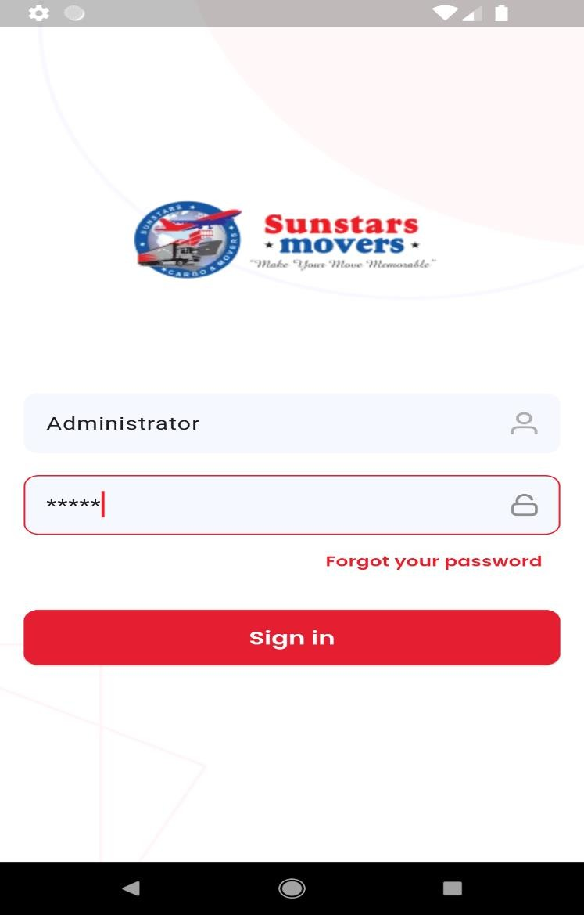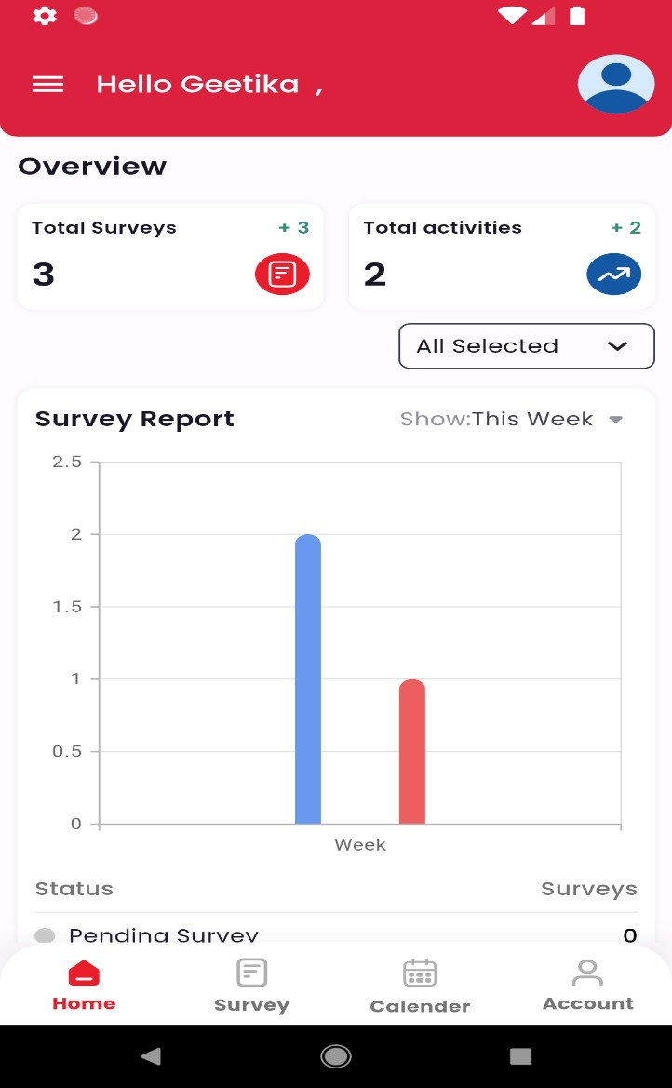

a) Login Page b) HomePage

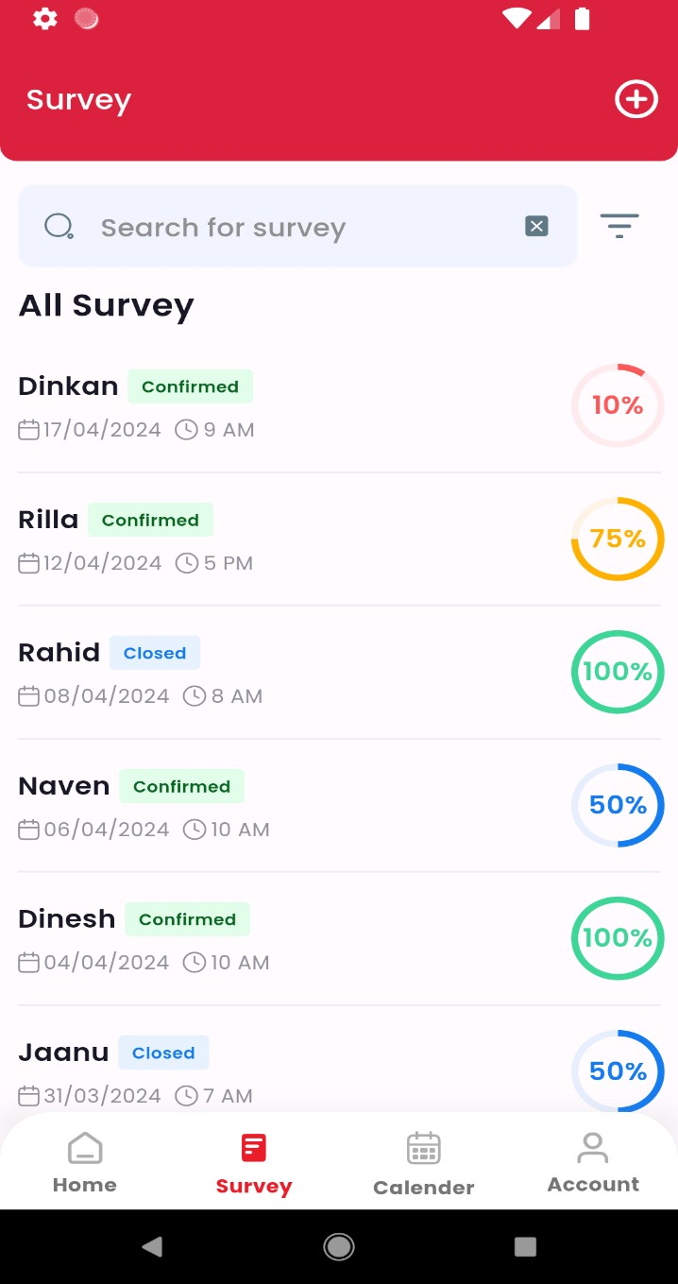 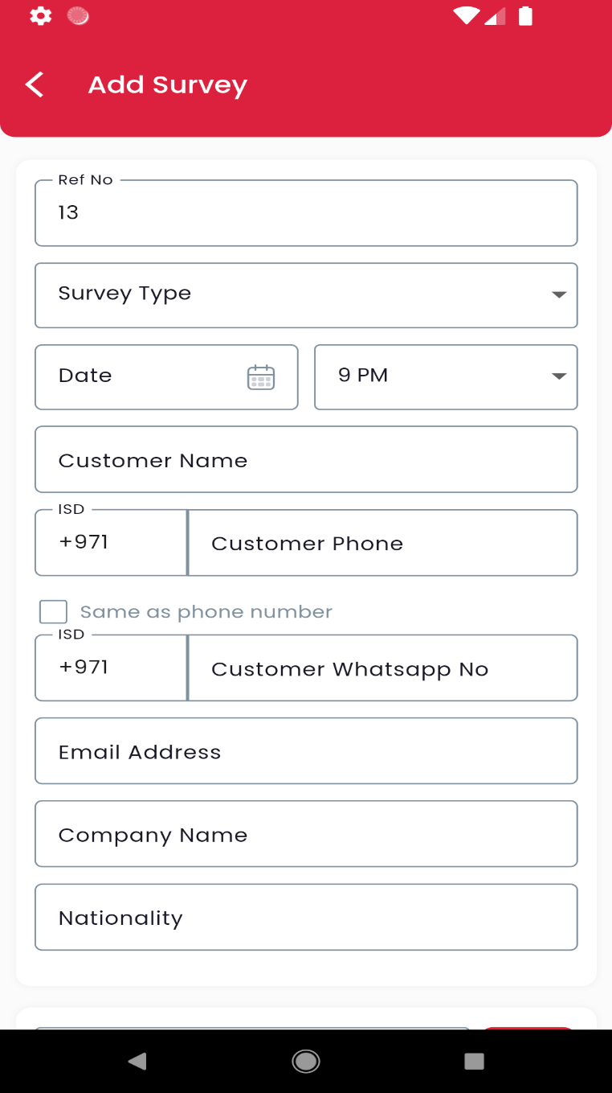

c) Survey d) Add Survey

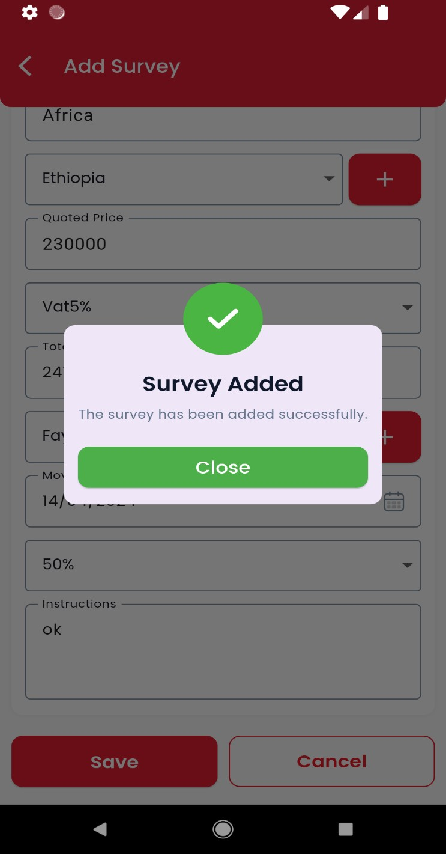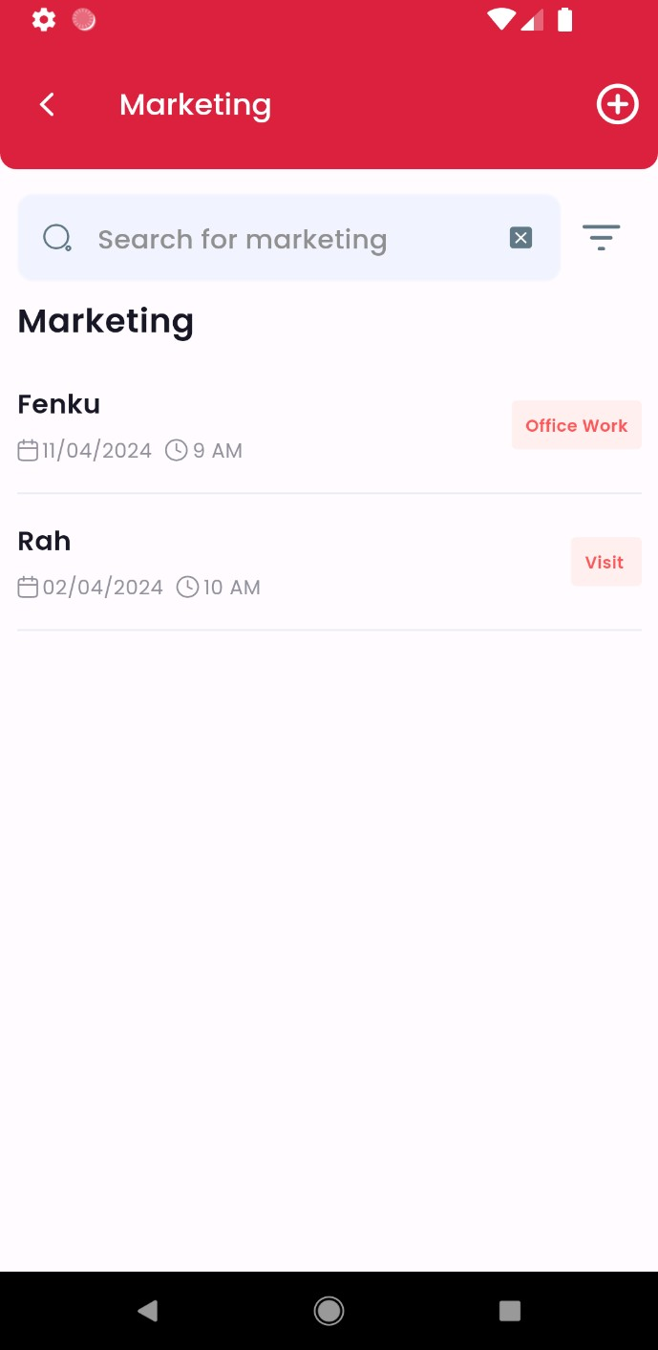

e) Survey Added f) Marketing

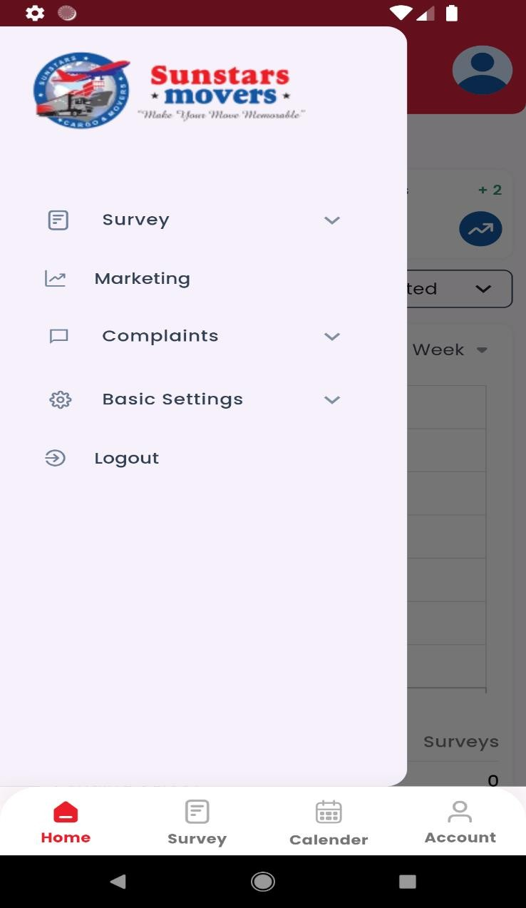 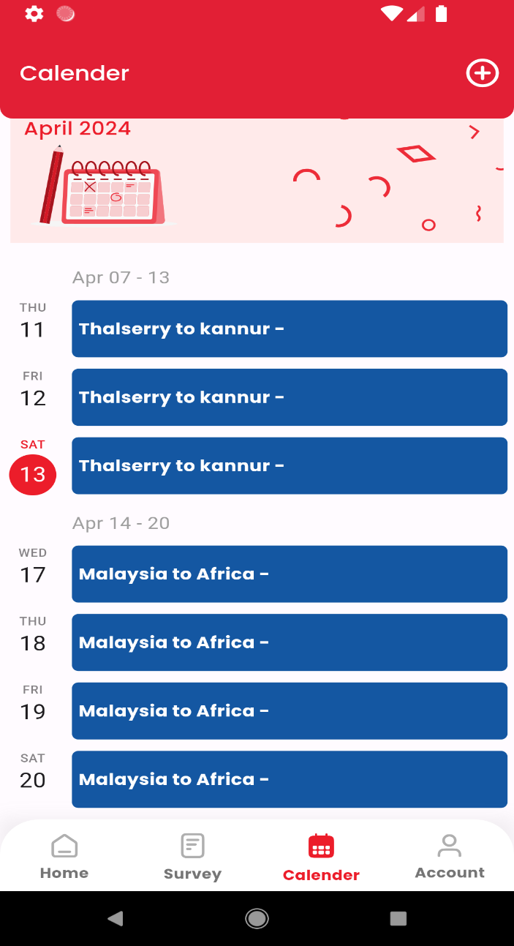

1. Menu h)Calender

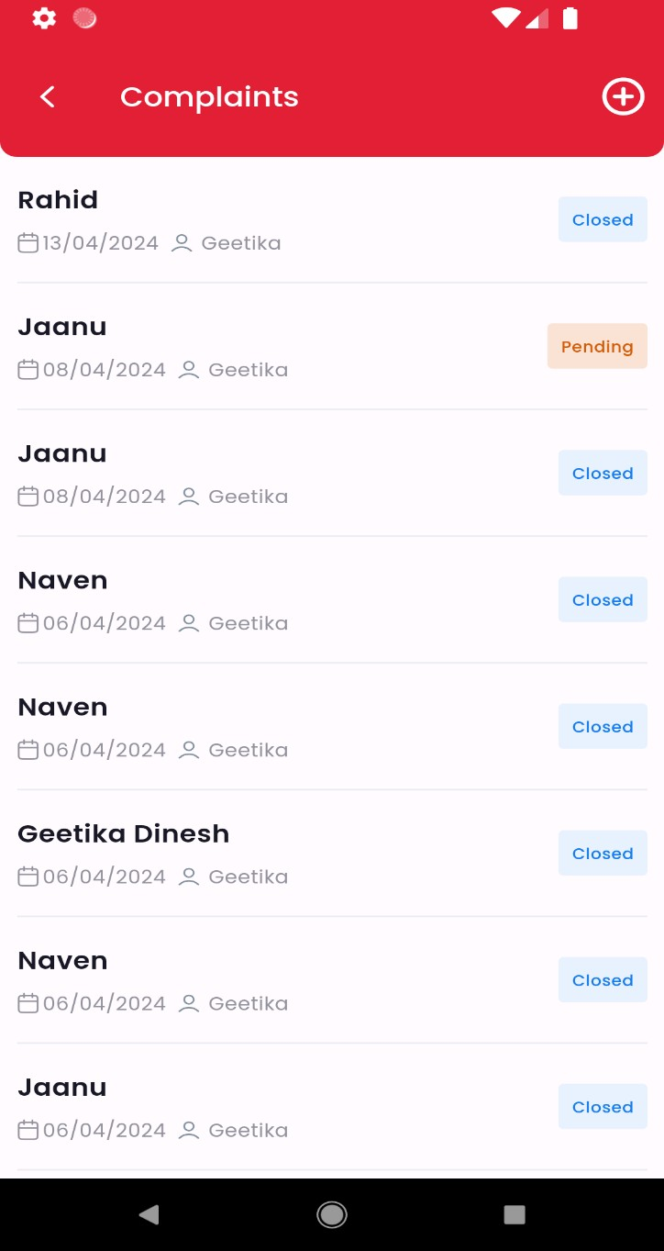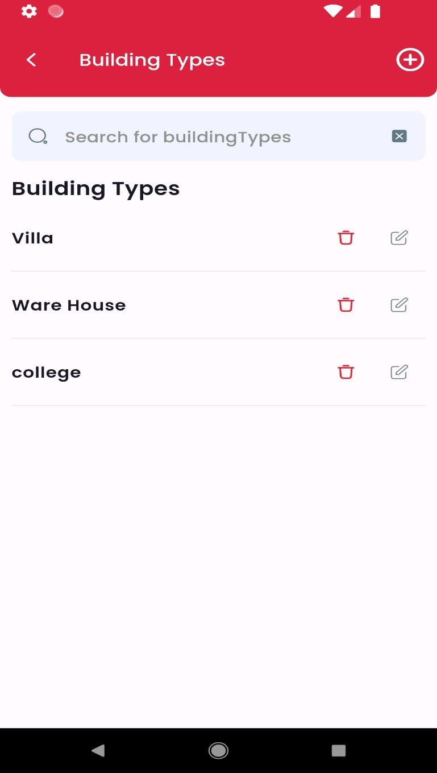

* 1. Complaints j) Basic Settings

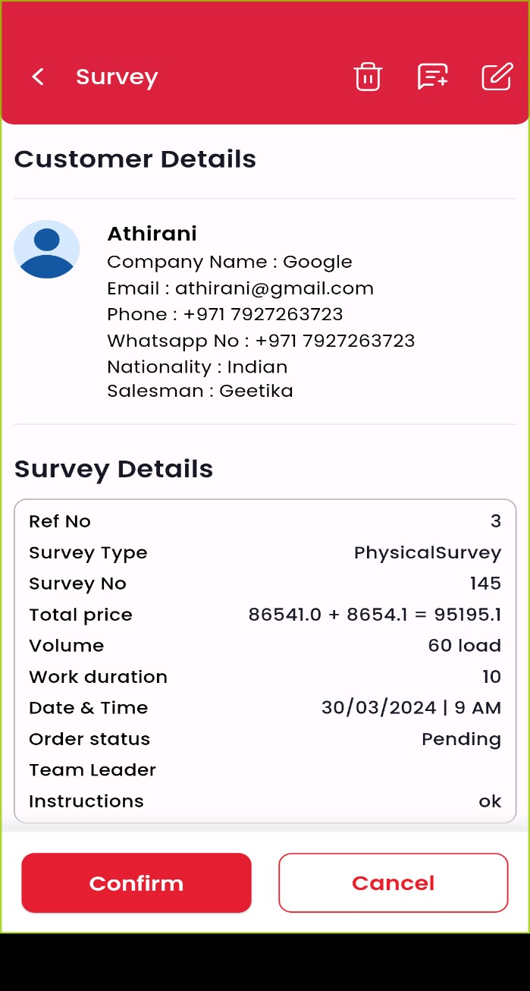 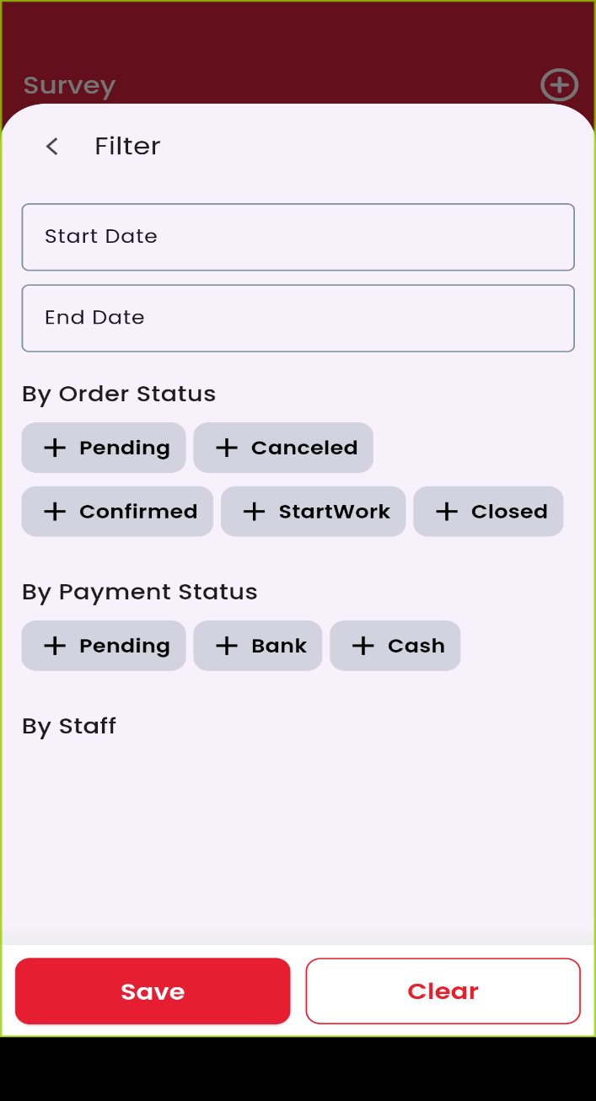

k) Survey Details l) Survey Filter

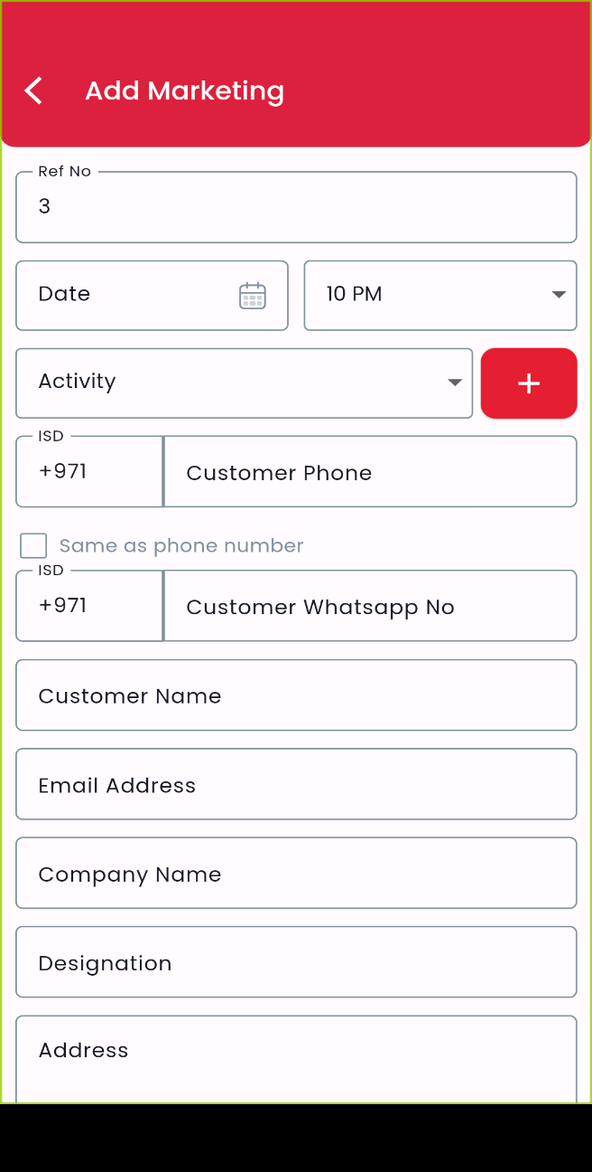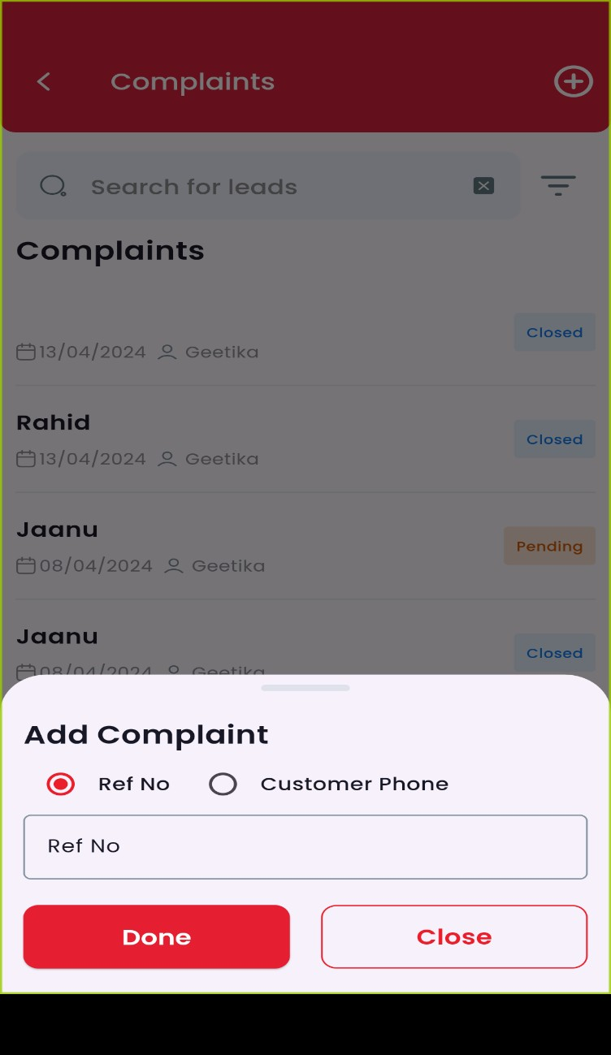

m) Add Marketing n) Add Complaint

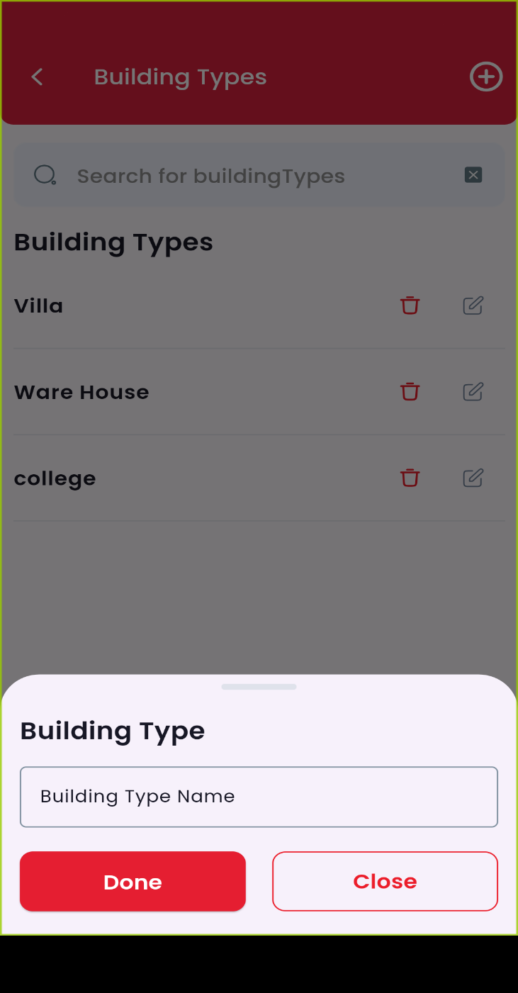 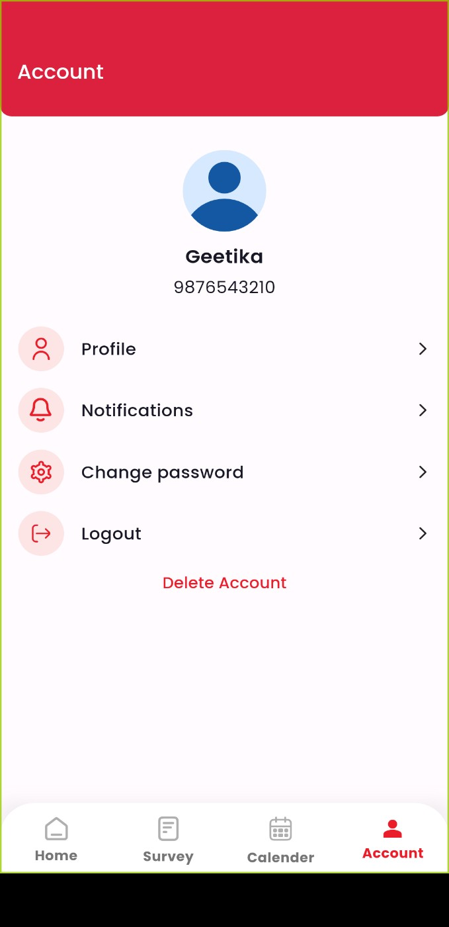

o) Add Building Type p) Profile

# Chapter 7 REFERENCES

1.https://[www.nobroker.in/packers-and-](http://www.nobroker.in/packers-and-) movers/?relocationType=INTRA_CITY&utm_source=google&utm_medium=cpc&utm_campaign=PMax_P nM_Gurgaon_GA4_Lead&gad_source=1&gclid=Cj0KCQjw2uiwBhCXARIsACMvIU1jCqf5F0X2GrYGK 3dwNEbG7sc2zmce3y8lVl0XEjSdRk90IRlSB_waArjCEALw_wcB

2 https://[www.globemoving.net/services/intercity-](http://www.globemoving.net/services/intercity-) moving/?gad_source=1&gclid=Cj0KCQjw2uiwBhCXARIsACMvIU39g1cvTTTo2j1CuUPPhJAAD09vxxTt H98uanLxYVQAOXBjLV7-8i8aAt2DEALw_wcB

3https://marianpackersandmovers.com/?gad_source=1&gclid=Cj0KCQjw2uiwBhCXARIsACMvIU3Iy5Wd c4Zpts4iUwrJXVTvjOG_yOJiR4fGm61aak07fG2L56FoVU8aAloaEALw_wcB

4 https://[www.agarwalpackers.com/](http://www.agarwalpackers.com/)

5. https://github.com/Niranjani29/Android-Application